Alerts
This section will provide details about the Alert features build into the BUG mod. Here is a screenshot of the options screen:
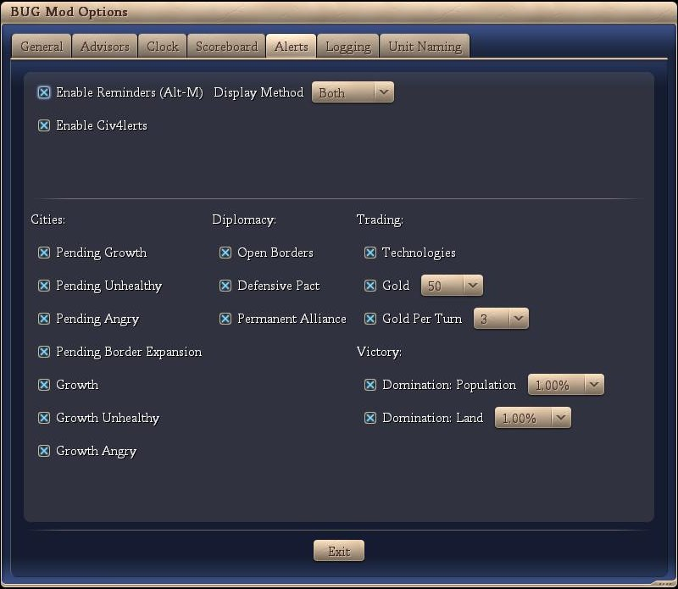

Reminders
The individual Reminder features are discussed below:
- Enable Reminders (Alt-M)
If this options is checked, then the Reminder portion of BUG is enabled. You can store a reminder via Alt-M on the keyboard. This will bring up a dialog box (see below) and you can set a reminder text as well as a reminder turn.
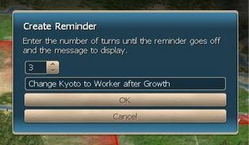
Then after the number of turns you specify, another dialog box pups up (see below – note this is not the show associated with the above dialog box) with your reminder. Reminders are stored across saves.
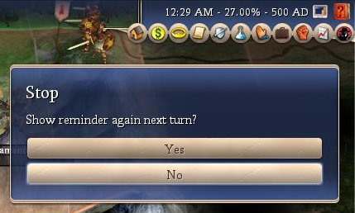
You can set the same reminder to appear next turn if you so desire.
- Display Method
This is the display method for the reminder. The options are:
- dialog box (as above)
- message on screen with other Civ4 messages
- both

Alerts
The individual Alert features are discussed below:
- Enable Civ4lerts
If this options is checked, then the Civ4lerts portion of BUG is enabled.
- Cities
  - Pending Growth
If checked, an alert that a city will grow next turn is displayed.
  - Pending Unhealthy
If checked, an alert that a city will grow into unhealthy (or further into unhealthy) next turn is displayed.
  - Pending Angry
If checked, an alert that a city will grow into anger (or further into anger) next turn is displayed.
  - Pending Border Expansion
If checked, an alert that a city border expansion will occur next turn is displayed.
  - Growth
If checked, an alert that a city has grown this turn is displayed.
  - Growth Unhealthy
If checked, an alert that a city has grown into unhealthy (or further into unhealthy) is displayed.
  - Growth Angry
If checked, an alert that a city has grown into anger (or further into anger) is displayed.
- Diplomacy
  - Open Borders
If checked, an alert that a civilization will sign open borders is displayed (first turn that option is available only).
  - Defensive Pact
If checked, an alert that a civilization will sign a defensive pact is displayed (first turn that option is available only).
  - Permanent Alliances
an alert that a civilization will sign a permanent alliance is displayed (first turn that option is available only).
- Trading
  - Technologies
If checked, an alert that a technologies to trade is displayed (first turn that tech is available only).
  - Gold
If checked, an alert that a civilization has gold to trade is displayed (each turn) – the user can set the limit of the alert.
  - Gold per Turn
If checked, an alert that a civilization has gold per turn to trade is displayed (each turn) – the user can set the limit of the alert.
- Victory
  - Domination: Population
If checked, an alert that you are approaching or exceeded the population domination limit - user can set the amount below the population domination limit that activates the alert.
  - Domination: Land
If checked, an alert that you are approaching or exceeded the land domination limit - user can set the amount below the land domination limit that activates the alert.

Conclusion
Opinion: It is our opinion that no additional information is presented to the user via this section of the BUG mod and it should be approved.

